# <http://practice.geeksforgeeks.org/company-tags>

# Q=Count triplets with sum smaller than a given value

[**2.7**](http://www.geeksforgeeks.org/easy/)

Given an array of distinct integers and a sum value. Find count of triplets with sum smaller than given sum value. Expected Time Complexity is O(n2).

Examples:

Input : arr[] = {-2, 0, 1, 3}

sum = 2.

Output : 2

Explanation : Below are triplets with sum less than 2

(-2, 0, 1) and (-2, 0, 3)

Input : arr[] = {5, 1, 3, 4, 7}

sum = 12.

Output : 4

Explanation : Below are triplets with sum less than 4

(1, 3, 4), (1, 3, 5), (1, 3, 7) and

(1, 4, 5)

<http://www.geeksforgeeks.org/count-triplets-with-sum-smaller-that-a-given-value/>

# Q=Find the subarray with least average

[**1.8**](http://www.geeksforgeeks.org/basic/)

Given an array arr[] of size n and integer k such that k <= n.

Input: arr[] = {3, 7, 90, 20, 10, 50, 40}, k = 3

Output: Subarray between indexes 3 and 5

The subarray {20, 10, 50} has the least average

among all subarrays of size 3.

Input: arr[] = {3, 7, 5, 20, -10, 0, 12}, k = 2

Output: Subarray between [4, 5] has minimum average

<http://www.geeksforgeeks.org/find-subarray-least-average/>

# Reverse vowels in a given string

[**2**](http://www.geeksforgeeks.org/easy/)

Given a string, your task is to reverse only the vowels of string.

Examples:

Input : hello

Output : holle

Input : hello world

Output : hollo werld

<http://www.geeksforgeeks.org/reverse-vowels-given-string/>

# Get the first letter of each word in a string using regex in Java

[**2**](http://www.geeksforgeeks.org/easy/)

Given a string, extract the first letter of each word in it. “Words” are defined as contiguous strings of alphabetic characters i.e. any upper or lower case characters a-z or A-Z.

Examples:

Input : Geeks for geeks

Output :Gfg

Input : United Kingdom

Output : UK

<http://www.geeksforgeeks.org/get-first-letter-word-string-using-regex-java/>

# Reverse words in a given string

[**2.6**](http://www.geeksforgeeks.org/easy/)

Example: Let the input string be “i like this program very much”. The function should change the string to “much very program this like i”

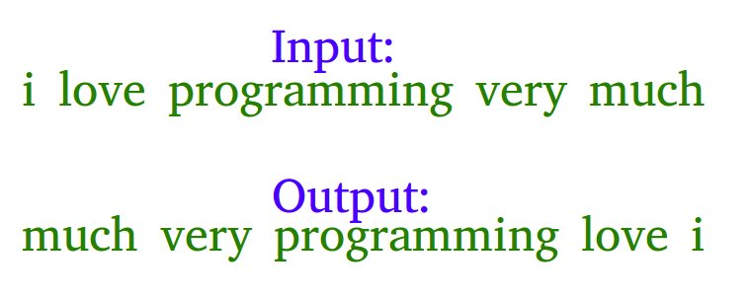

Examples :

Input : s = "geeks quiz practice code"

Output : s = "code practice quiz geeks"

Input : s = "getting good at coding needs a lot of practice"

Output : s = "practice of lot a needs coding at good getting"

<http://www.geeksforgeeks.org/reverse-words-in-a-given-string/>

# Reverse string without using any temporary variable

[**2.7**](http://www.geeksforgeeks.org/easy/)

We are given a string. We are also given indexes of first and last characters in string. The task is to reverse the string without using any extra variable.

Examples:

Input : str = "abc"

Output : str = "cba"

Input : str = "GeeksforGeeks"

Output : str = "skeeGrofskeeG"

<http://www.geeksforgeeks.org/reverse-string-without-using-any-temporary-variable/>

# Check if a string can be obtained by rotating another string 2 places

[**1.5**](http://www.geeksforgeeks.org/basic/)

Given two strings, the task is to find if a string can be obtained by rotating another string two places.  
Examples:

Input : string1 = "amazon"

string2 = "azonam" // rotated anti-clockwise

Output : Yes

Input : string1 = "amazon"

string2 = "onamaz" // rotated clockwise

Output : Yes

# Minimum cost to convert string into palindrome

Convert string S into a palindrome string. You can only replace a character with any other character. When you replace character ‘a’ with any other character, it costs 1 unit, similarly for ‘b’ it is 2 units ….. and for ‘z’, it is 26 units. Find the minimum cost required to convert string S into palindrome string.

Examples:

Input : abcdef

Output : 6

Explanation: replace 'a', 'b' and

'c' => cost= 1 + 2 + 3 = 6

Input : aba

Output : 0

<http://www.geeksforgeeks.org/minimum-cost-convert-string-palindrome/>

# Using Set() in Python Pangram Checking

Given a string check if it is Pangram or not. A pangram is a sentence containing every letter in the English Alphabet. Lowercase and Uppercase are considered the same.

Examples:

Input : str = 'The quick brown fox jumps over

the lazy dog'

Output : Yes

// Contains all the characters from ‘a’ to ‘z’

Input : str='The quick brown fox jumps over the dog'

Output : No

// Doesn’t contains all the characters from ‘a’

// to ‘z’, as ‘l’, ‘z’, ‘y’ are missing

<http://www.geeksforgeeks.org/using-set-python-pangram-checking/>

# Q=Maximum consecutive repeating character in string

Examples:

Input : str = "geeekk"

Output : e

Input : str = "aaaabbcbbb"

Output : a

<http://www.geeksforgeeks.org/maximum-consecutive-repeating-character-string/>

### Print Natural numbers using two Even-Odd printing Thread

<http://javaexplorer03.blogspot.in/2015/11/print-natural-numbers-using-two-even.html>

# Printing numbers in sequence from alternating threads